[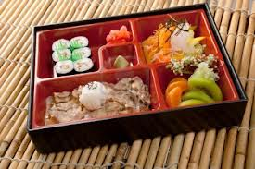](http://www.google.com/imgres?q=lunch+box+image&start=150&hl=en&sa=X&rls=com.microsoft:en-us:IE-SearchBox&biw=1202&bih=642&tbm=isch&tbnid=jwbV4MdKsbItHM:&imgrefurl=http://www.123rf.com/photo_10998164_japanese-bento-lunch-box-of-fast-food-with-with-pork.html&docid=4flwfjSsZxLDOM&imgurl=http://us.123rf.com/400wm/400/400/fanfo/fanfo1110/fanfo111000202/10998164-japanese-bento-lunch-box-of-fast-food-with-with-pork.jpg&w=1200&h=798&ei=yP84Uen0EI_e8wTg-IHoBw&zoom=1&iact=rc&dur=187&page=7&tbnh=141&tbnw=221&ndsp=27&ved=1t:429,r:57,s:100,i:175&tx=148&ty=74)[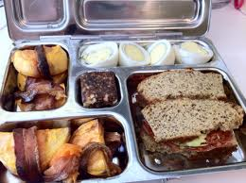](http://www.google.com/imgres?q=lunch+box+image&start=150&hl=en&sa=X&rls=com.microsoft:en-us:IE-SearchBox&biw=1202&bih=642&tbm=isch&tbnid=k0NxCjRo7G07TM:&imgrefurl=http://mypaleolunchboxes.wordpress.com/category/lunchbox/long-day-lunchbox/&docid=5vZKtsvqR3gh0M&imgurl=http://mypaleolunchboxes.files.wordpress.com/2011/09/lunch-box-7.jpg&w=2592&h=1936&ei=yP84Uen0EI_e8wTg-IHoBw&zoom=1&iact=rc&dur=407&page=7&tbnh=145&tbnw=191&ndsp=27&ved=1t:429,r:67,s:100,i:205&tx=100&ty=86)

Name:

3.C.1.1 – Compare languages, foods and traditions of various groups living in local and regional communities.

As part of our Cultural Unit, we are learning about what different cultures eat. Your mission is to find out more about your family’s culture (ask your parents, or grandparents) about a special dish that is traditionally from that culture. For example: An American sandwich is PB&J sandwich, whereas a Japanese lunch might have noodles.

Your challenge is to find out at least one MAIN dish, one SWEET/DESSERT item and one FRUIT/VEGETABLE. Extra credit if you have the actual food (not a photo or picture)

Make sure that you label the lunch box with the country of origin. A recipe written up or typed up of the main dish is expected. Please check rubric on the back to make sure you get full marks!

Cultural Lunch Boxes

My Cultural Lunch Box

Main Lunch

Dessert

Fruit/Veg