Name: ______________________Date:_______________
Journal Pizza Prompt -HW

Tessa and Andy were talking about how much pizza they ate last night at the party. They were trying to figure out who ate more.
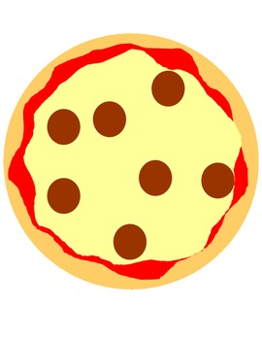
- Tessa at 2/3 of a small pizza. Andy ate 4/6 of a small pizza.
- Andy said he ate more because 4/6 is bigger than 2/3 because the denominator and the numerator are both larger.
- Tessa thinks they ate the same amount because the 4/6 and 2/3 are equivalent fractions.

Who do you agree with? Why? Who is right?
Make sure you prove your thinking with precise vocabulary and by making a visual model to prove it!

